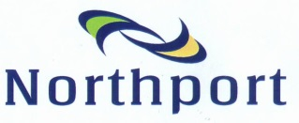

Notice to all Users of the Northport Gantries
August 2021
Gantry Compliance - Renewal

Purpose of the Gantry Compliance Process:
Safe lifting equipment and competent operators are both essential for minimising the risk to users of the Northport Limited (“Northport”) gantries. The gantry compliance system is in place to protect gantry users from unsafe gantry practices and substandard components. By ensuring only trucks with compliant lifting gear and a trained operator use the gantries.
Lifting gear on trailers using the Northport gantries should be checked before every use and inspected at least annually in accordance with the requirements of the Code of Practise for load lifting and rigging and the Log Transport Safety Council’s guidelines.
Trucking Companies shall:
1: Provide a copy of the inspection register detailing;
- Company Name, physical address and email address
- Full name of the competent person conducting the inspection
- Date the inspection took place
- Registration numbers of the truck and trailer being inspected
- Fleet number
2: When provided with an individually numbered “Gantry Compliance” sticker by Northport, remove the previous (yellow) sticker if applicable and apply the new (RED) sticker in the bottom corner of the driver’s side of the truck’s windscreen. Also, for operators with multiple trucks or trailers, ensure the correct sticker is matched with between trucks and trailers as per register submitted.
3: Notify Northport immediately where any details of the trailer registration versus sticker number changes due to swapping trailers or for any other reason.
4: By using the Northport gantries, ensure that their drivers are trained in and comply with the Northport Gantry Operating Procedures, which are displayed at the Gantries and attached on page 4 of this letter. Note that the Western gantry has an SWL of 8T and the Eastern gantry has an SWL of 10T. Issues noted during our gantry safety days are provided in Appendix 4 to support this training.

Note:
- Competent Person – Means a person who has acquired, through a combination of qualifications, training and experience, the knowledge and skill to perform the required task.

- Inspection Register – May be in the form of Microsoft Excel spread-sheet (provided in Appendix 3), accompanied by a covering letter signed by a duly authorised person within that Company stating their name and position. Or (for smaller fleet operators/ owner-drivers) all inspection details on a single letter as above. A blank template for this return is provided in Appendix 2.
For information:
- Northport have worked with the Log Transport Safety Council (LTSC) and Northland Freight Group to ensure the highest practicable standards are achieved at our gantries. Operator training and using appropriate, well maintained equipment is essential for this to be achieved.

- The LTSC have implemented their own standards for safe gantry use however a Northport ‘Gantry Compliance’ sticker is the only acceptable proof of compliance for using the Northport gantries.

Only Trucks displaying a red Northport Ltd ‘Gantry Compliance Expiry: 31 AUG 2022’ sticker will be permitted to use the Northport Gantries from 30th September 2021.
Any queries, please contact Northport Limited on hse@northport.co.nz

Example of valid sticker for the period 1/9/2021 – 31/8/2022
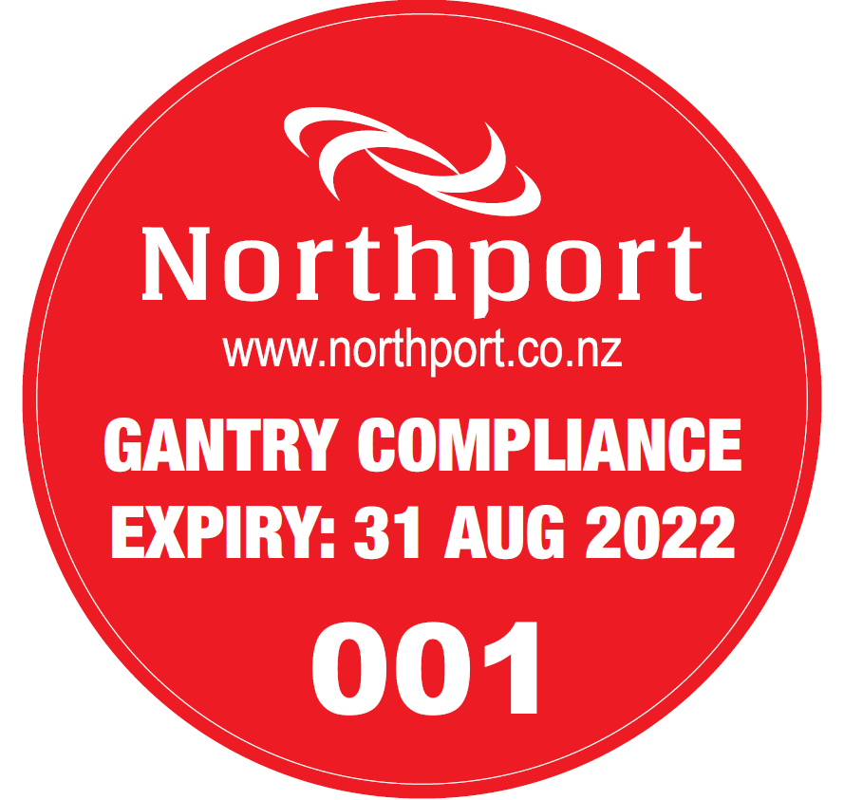
Yellow stickers are no longer valid after 30/9/2021

Risk Register – Northport Limited Gantry Operations

Risk | Controls / Rules
Raised Trailer  (Suspended Load) | Operator to ensure they and any bystanders or assistants are as far as practicable from the suspended load (trailer). Working under a raised trailer will result in serious harm or death should the trailer drop for any reason.
Damaged or non-compliant Lifting Chains | Trailer lifting chains must be certified and compliant with LTSC standards with respect to grade and configuration. and inspected by a competent person at least annually. Additionally, the operator is required to inspect the chains for visual defects prior to each lift.
Traffic | Gantry operators to be aware of other trucks and mobile plant in the vicinity of the gantry to ensure no interactions between their operation and the adjacent gantry, fuel pumps, roadway or log yard. Workers must wear hi-vis at all times at Northport and light vehicles are required to display an amber flashing light.
Dropped Items | Clear loose bark and debris off trailer before lifting. Hard hat and protective footwear are mandatory within the gantry area.
Trailer Swinging | Waiting trucks must stop before the marked white line. The operator and other workers must stay well clear of the swing zone during a lift.
Pinch Points | When rotating the drawbar ensure you are not caught between the drawbar and the trailer or gantry frame. The momentum of a rotating drawbar or swinging trailer can cause serious injury upon impact. Gloves to be considered by the operator to mitigate the risk of hand injuries from pinching or abrasion.
Trailer Debris | Watch for trailer debris. Failure to notice debris may result in an injury from tripping. Keep area clean and tidy and consider glasses if conditions are dusty.
Slips/Trips/Falls | Take care and use three points of contact when removing the lifting ring from the trailer and when accessing and egressing from your cab.
Other people | Ensure non-approved persons are not in proximity to the lifting area. The operator is responsible for ensuring the gantry and bystanders are safe to use.
Manual Handling | Maintenance of the trailer and lifting hardware for ease of movement. Correct technique is important to minimise stress on the body. Consider assistance from a second competent gantry operator (when available).
Emergencies | Port Alarm site adjacent to the Western gantry. Full 24/7 camera surveillance. Port Services and Refining NZ available 24/7 for fast and effective support.
Unauthorised modification to gantry components | Gantry operators must not modify any aspect of the Northport gantry or gantry hook. Drivers are required to perform a pre-operational check of their lifting gear and the gantry with any faults reported to Northport Ltd prior to use. Full 24/7 camera surveillance and proximity to the Port Services Centre support compliance.

FOR ADVICE OR TO REQUEST ASSISTANCE: CALL PORT SERVICES 09 432 5018 (24/7)

Appendix 1: Northport – Gantry Operating Procedure
(Note: Western Gantry SWL is 8T, Eastern Gantry SWL is 10T)
Northport Limited
Gantry Operating Procedure
1: | Before using Northport Gantries all Drivers must be fully trained and competent with using this operating procedure.
2: | Personal Protective Equipment must be worn at all times. Hi-visibility clothing, safety boots and safety helmet are mandatory PPE. Gloves and safety glasses to be considered by the operator.
3: | Drivers must inspect all lifting equipment before lifting takes place. (Perform inspection of chains, lifting rings, anchor points and gantry wires, etc.).
4: | If someone is helping you, communicate clearly and agree actions before operating.
5: | Never operate the gantry with anyone under or on the other side of your trailer. Moving under a suspended trailer is prohibited at all times and the operator is responsible for knowing the whereabouts of any persons assisting.
6: | Trailer lifting ring must be under hook before lifting. If too far forward a siren will sound disabling the raise function. In this case, lower and reposition your trailer.
7: | Swipe Dallas Tag to start. LEDs on electrical control box show if system is active or emergency stop has been activated.
8: | Stand clear when lifting the trailer. Be aware that the trailer could swing.
9: | When turning drawbar, trailers must be as close as possible to the ground. The drawbar is to be pushed and the operator must never position themselves between the drawbar and the trailer or gantry frame.
10: | When unhooking trailer take appropriate care when climbing onto the truck.
11: | Please raise hook fully and remove all bark from the trailer before leaving area.
12: | Any damage or incident must be reported to the Port Service Centre immediately.
Note: | It is strictly forbidden to alter the gantry hardware (e.g.: hooks) in any way. The gantries are under video surveillance and breaches may result in exclusion.
If in doubt, stop and contact Port Services on 09 432 5018.

Appendix 2: Inspection Register – Memo to Northport
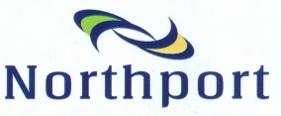

Memorandum

TO: | Northport Ltd
SUBJECT: | Gantry Compliance

This memo confirms that we have read and understood the information provided by Northport and attach our trailer inspection register.

Company Name:_________________________________________

Competent Person:_______________________________________

Company Representative:_________________________________

Signature: _____________________________________________

Date: _________________________________________________

Please complete the above and scan/email back to hse@northport.co.nz with “Gantry Compliance” in the subject heading.

Appendix 3: Trailer Inspection Register
TRAILER INSPECTION REGISTER
COMPANY NAME:
PHYSICAL ADDRESS:
EMAIL ADDRESS:
PHONE NUMBER:
FLEET ID | TRUCK REGO | TRAILER REGO | INSPECTOR | DATE OF INSPECTION | SIGNATURE OF INSPECTOR (Driver and Equipment Compliant)

Appendix 4: Previously observed issues at the Gantries
Issue 1: Main lifting chains are too short. Main lifting chains need to be long enough that an angle of less than 120° is created between these chains below the main lifting ring.
Issue 2: Damage to chain links on the main lifting chain especially adjacent to the master ring. Damage in the region of the bridle chains is less common but is still possible.
Issue 3: Hammerlocks are only designed to have a single link coupled with each section. Overloading hammerlocks causes uneven forces through the pivot points which can lead to failure.
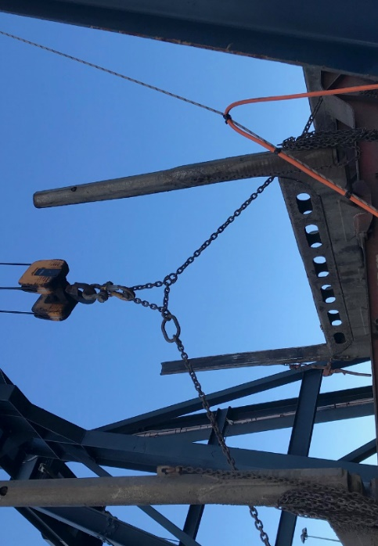
Issue 4: Incorrect set up of the lifting rig. Many improvements noted during annual Gantry Safety Days. Please ensure that lifting chains are grade 100 and compliant with LTSC standards. Lashing chains must also be at least 6mm and in good condition. Correct configuration is also essential, see example below:
This setup was recently seen at the gantry
1) No use of lifting ring on hook
2) Overloaded hammerlock
3) Twist in chain
4) Focal loading of chain.

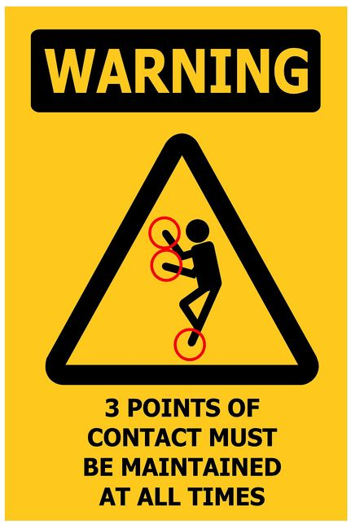
Issue 5: Slips, trips and falls. During 2020/21, there have
been 2 incidents where drivers have slipped
from their truck while at the gantries. Northport
is investigating other options (e.g.: fixed
platform or automatic hook) while remaining
compliant with Worksafe’s ACOP for safe lifting
and rigging, but in the interim, please remind
drivers to have 3 points of contact at ALL times
when climbing on or off their truck.

