Pilot Card

Voy No.: 2506 | Port & Country: MARSDEN POINT,NZ |  |  |  | Date:23/09/2025
Agent Details: INCHCAPE SHIPPING SERVICES/ Chris Silk +64 27 4822152
SHIP PARTICULARS
Name: YANGTZE DIGNITY |  |  |  |  | Call Sign: VRJW5
Displacement:33843.6MT |  | DWT:24598.6MT |  |  | Year Built: 2011
Length: 179.9 M |  | Beam:28.39 M |  |  | Bulbous Bow: YES
Draught Fwd:7.82m |  | Draught Aft:8.45m |  |  | Draught Amidships:9.06m
Air Draught:33.0m |  | Port Anchor: 11 Shackles |  |  | Starboard Anchor: 11 Shackles
Bow Blind distance: LOADED:172.74 m BALLAST:295.3 m 1 shackle = 27.5 m/15 fathoms
27.7m | 152.2m  Manifold Parallel W/L  Loaded 174.81 m  Ballast 118.30 m
28.4 m |  |  |  | Air draught  33.0m m |  |  | 42.1 m
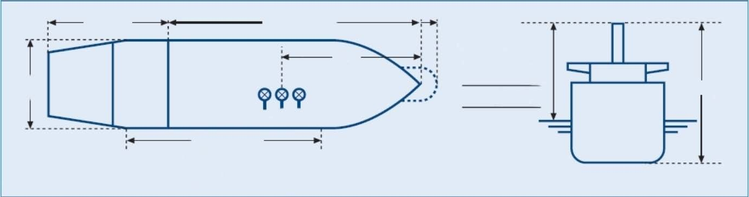
MAIN ENGINE
Type: M.A.N. - B&W 6S42MC  F.P.P. Keyless (KIS), Diam:6000mm |  | Max Power:EPL 4210 |  | kW | Max Power: |  | HP
 |  | RPM/Pitch |  | Loaded Speed (kts) |  | Ballast Speed(kts)
SEA Full Ahead: |  | 117 |  | 12.0 |  | 12.5
Full Ahead: |  | 108 |  | 11.2 |  | 12.1
Half Ahead: |  | 90 |  | 9.5 |  | 9.9
Slow Ahead: |  | 75 |  | 7.5 |  | 7.5
Dead Slow Ahead: |  | 50 |  | 5.0 |  | 5.0
Dead Slow Astern: |  | 48
Slow Astern: |  | 75
Half Astern: |  | 83
Full Astern: |  | 90 |  | 40% ahead power
Engine Critical RPM:56-69 |  | Maximum Number of Consecutive Engine Starts:12 |  |  | Time from Full Ahead to Full Astern: 540s
Time Limit Astern: MIN |  |  | Minimum Steering Speed: 4.5kt

Cont.-
STEERING
Number of Propellers: 1 |  | Direction of Turn:  Right Handed |  |  |  |  | Propeller Arrangement: CENTRE
Time from Hard-Over to Hard-Over: s |  |  |  | Rudder Angle for Neutral Effects: degrees
Thrusters (Positions and Power): N/A |  |  |  | Steering Characteristics: SEMI-SPADE
EQUIPMENT CHECKED AND READY FOR USE
Anchors: |  |  |  |  |  |  |  | Cleared Away: YES
Compasses: |  |  |  |  |  |  |  | YES  0
Compass Error:
Speed Log: |  |  |  |  |  |  |  | Doppler: YES/  Speed: Water/Ground  Axis: Single/Dual
Echo Sounder: |  |  |  |  |  |  |  | YES
GNSS: |  |  |  |  |  |  |  | Type:GPS
ECDIS: |  |  |  |  |  |  |  | TWO
X-Band Radar: |  |  |  |  |  |  |  | ARPA: YES
S-Band Radar: |  |  |  |  |  |  |  | ARPA: YES
VHF (Including Handheld): |  |  |  |  |  |  |  | YES
Steering Gear: |  |  |  |  |  |  |  | Number of Power Units In Use: 2
Engine Telegraphs: |  |  |  |  |  |  |  | YES  YES  YES  YES  YES
Rudder/RPM/ROT Indicators:
Mooring Winches and Lines:
Navigation Lights:
Whistles:
MOORING CONFIGURATION  (Indicate On Diagram Below) | FWD |  | NBR |  |  |  |  | AFT |  | NBR
MOORING CONFIGURATION  (Indicate On Diagram Below) |  |  | Head |  |  |  |  |  |  | Astern
MOORING CONFIGURATION  (Indicate On Diagram Below) |  |  | Breast |  |  |  |  |  |  | Breast
MOORING CONFIGURATION  (Indicate On Diagram Below) |  |  | Springs |  |  |  |  |  |  | Springs
 |  |  |  |  |  |  |  | (OBTAIN FROM PILOT) |  | TONNES | TUG NAME
MOORING DETALS/PLAN |  | MOORING WINCHES |  | 2+2 |  |  |  | TUG’S  BOLLARD  PULL | NO.1
 |  | MOORING BOLLARD |  | SWL |  | 64T |  | TUG’S  BOLLARD  PULL | NO.2
 |  | CLOSED CHOCK |  | SWL |  | 64T |  | TUG’S  BOLLARD  PULL | NO.3
 |  | ROLLER FAIRLEAD |  | SWL |  | 48T |  |  | NO.4
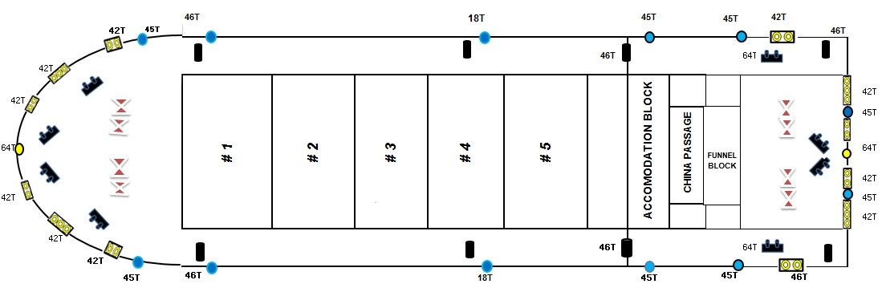

WHEN BOLLARD PULL OF THE TUGS EXCEED THE SWL OF SHIPS MOORING BOLLARDS PILOT/TUGS SHOULD BE ADVISED.
EQUIPMENT OPERATIONAL DEFECTS / OTHER IMPORTANT DETAILS
OTHER IMPORTANT DETAILS
Main Engine Power Limited with RPM 117
Completed by: Verified by : Acknowledged by:

Name: Master Pilot
Rank : Name :SHILONGFENG Date:

