30

Port Name MARSDEN POINT |  |  |  |  |  |  | Date 05/03/2025
Call sign V7PM2 |  |  | Dead weigh 24063 tonnes |  |  |  |  | Year built 2017
Draught aft 8.65 m/ ft in, |  |  |  |  | Forward6.75 m/ ft in, |  |  |  | Displacement 33262 tonnes

SHIP’S PARTICULARS
Length overall 182.0 m, Anchor chain: Port 11 shackles, Starboard 12 shackles,
Breadth 30.0 m Stern NIL shackles
Bulbous bow No (1 shackle = 27.5 m/ 15 fathoms)
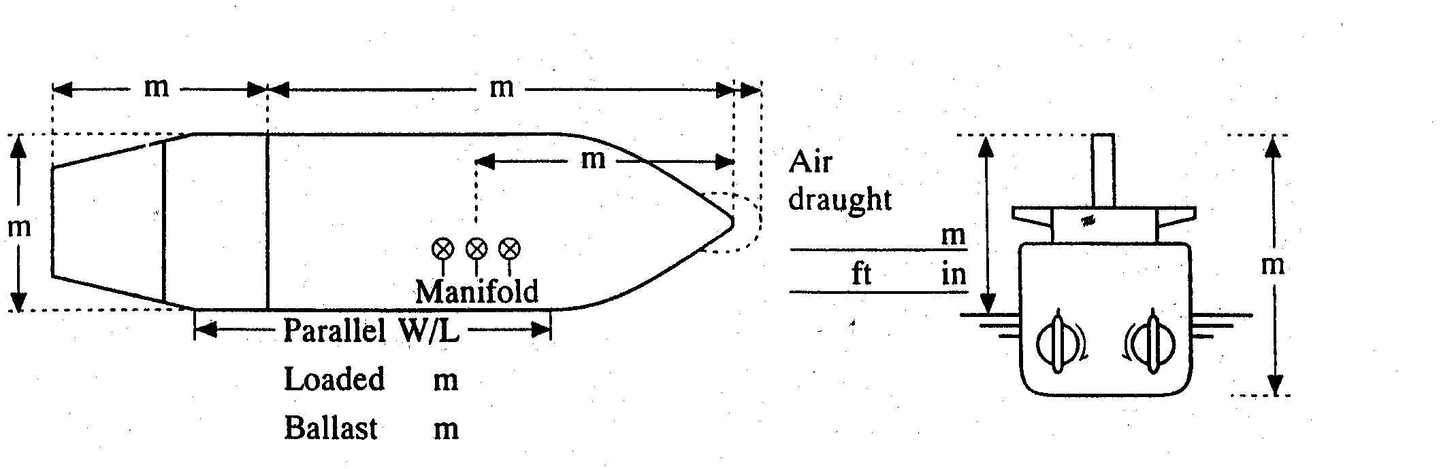
44.94
26.5
155.5
36.3M

 | Type of engine WARTSILA 5RT-flex50-D |  |  |  |  | Max. power 7044 kW ( 9583 HP)
 | Manoeuvring engine order |  |  | Rpm/pitch |  | Speed (knots)
 |  |  |  |  |  | Loaded |  |  |  | Ballast
 | Full ahead |  |  | 72 |  | 10.0 |  |  |  | 10.5
 | Half ahead |  |  | 51 |  | 6.0 |  |  |  | 7.0
 | Slow ahead |  |  | 44 |  | 5.5 |  |  |  | 6.0
 | Dead slow ahead |  |  | 35 |  | 4.0 |  |  |  | 4.5
 | Dead slow astern |  |  | 35 |  | Time limit astern |  |  |  | 30 min
 | Slow astern |  |  | 44 |  | Full ahead to full astern |  |  |  | 450 s
 | Half astern |  |  | 50 |  | Max. no. of consec. starts |  |  |  | 20
 | Full astern |  |  |  |  | Minimum RPM 28 |  |  |  | 3.2 knots
 |  |  |  | 72 |  | Astern power  CRITICAL RPM RANGE |  |  |  | 70 % ahead  53-67

STEERING PARTICULARS
Type of rudder SEML-BLANCED STREAM LINED Maximum angle 35
Hard-over to hard-over 19 s
Rudder angle for neutral effect 0 。
Thruster: Bow NIL kW ( HP) Stern NIL kW ( HP)

CHECKED IF ABOARD AND READY
 | Anchors | √ | Indicators:
 | Whistle |  | Rudder | 
 | Radar  3cm |  10cm | Rpm/pitch | 
 | ARPA |  | Rate of turn | 
 | Speed log  | Doppler: Yes | Compass system | 
 | Water speed |  | Constant gyro error | -0.1 。
 | Ground speed |  | VHF | 
 | Dual-axis |  | Elec. pos. fix. system | 
 | Engine telegraphs |  | Type | GP-150
 | Steering gear | 
 | Number of power  units operating | 
OTHER INFORMATION:
 |  | Yes | No
1 | Is the ship equipped with an engine or shaft power limiter? EPL or ShaPoli | V
 | If yes, is the limiter mechanical or software based? Limiter mechanical / Software based | V
 | • If the ship is equipped with a mechanical limiter, has it been removed or disabled prior to the pilot boarding the ship?
 | • If the ship is equipped with a software-based limiter, will the ship’s crew be able to override it immediately at the request of the pilot? | V
2 | Can the main engine/s attain the posted manoeuvring power (RPMs) without delay? | V
3 | Are the master and all bridge navigational watchkeepers familiar with the override feature for the EPL? | V
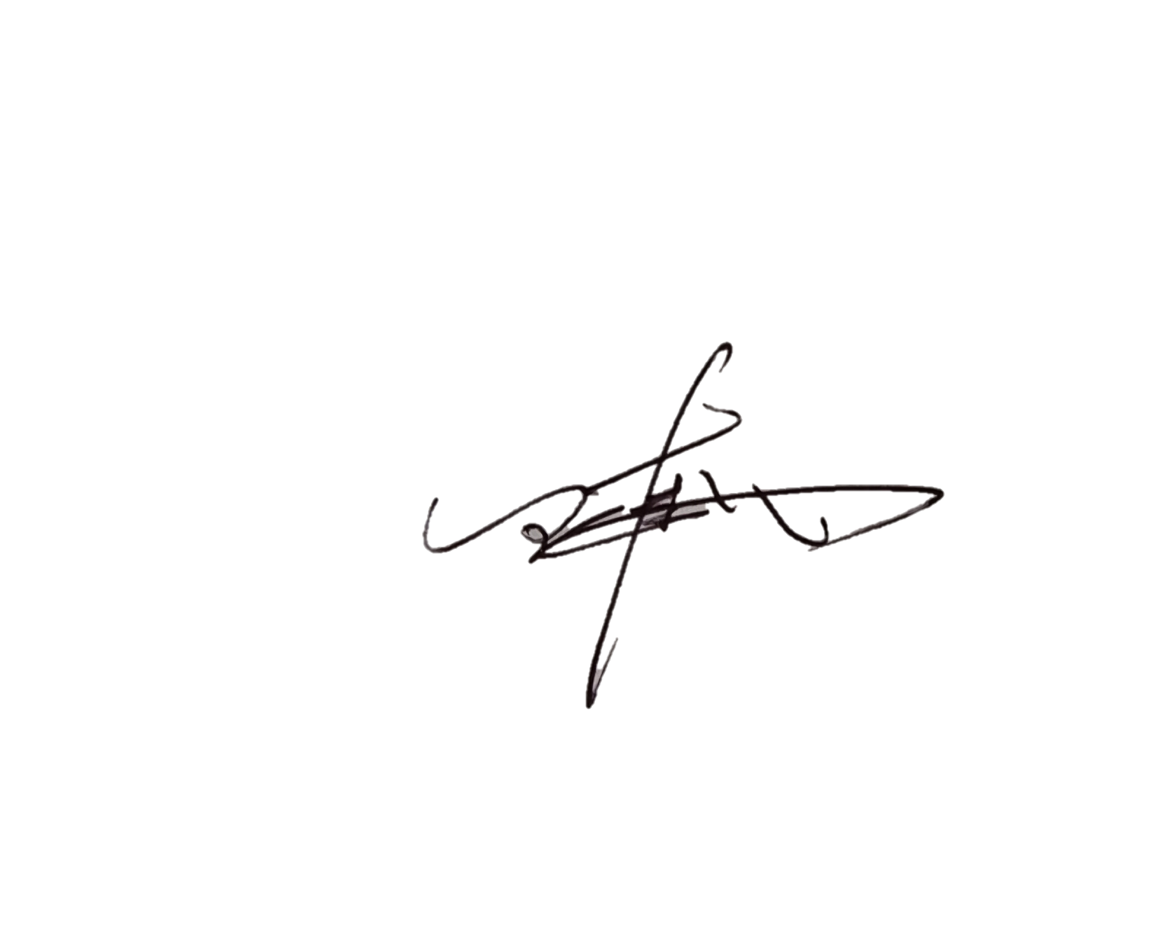  4 | Does the vessel have a risk assessment with appropriate control measures in place for immediate access to the EPL when full manoeuvrability is needed for safe passage? | V

Signature of Master Signature of Boarding Pilot

