SHIP PARTICULARS
Name: M.V WECO JOSEFINE |  | Call Sign: 9V5717
Displacement: 33661 MT | DWT: 38592 MT | Year Built: 2018
Length: 179.99 m | Beam: 30.00 m | Bulbous Bow: No
Draught Fwd: 6.69 m | Draught Aft: 8.69m | Draught Amidships: 7.69 m
Air Draught: m | Port Anchor: 12 Shackles | Stbd Anchor: 11 Shackles
1 shackle = 27.4m/15 fathoms
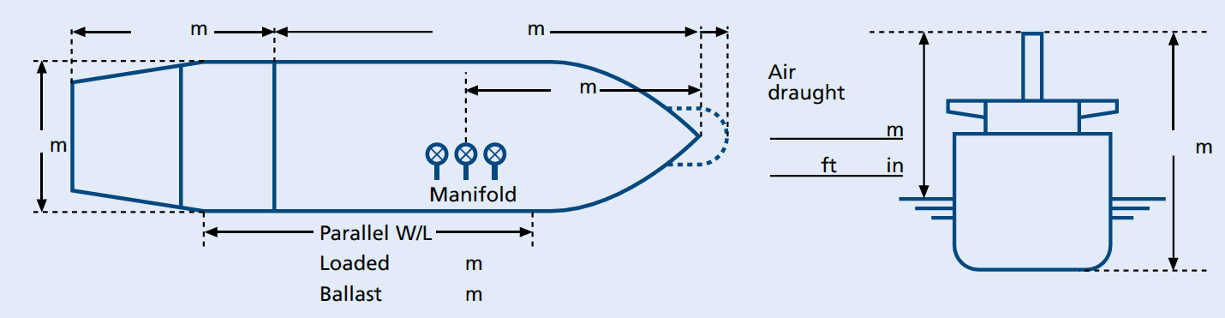
30.0

23.9

43.37
156.09
MAIN ENGINE
Type: MITSUI MAN-B&W 6S50ME-C8.5X1SET | Max Power: 6780 KW | Max Power: 9218 HP
Full Ahead: | 80 RPM/Pitch | Loaded Speed 11.3 (kts)  Sp | Ballast Speed 11.8 (kts)
Half Ahead: | 70 RPM/Pitch | 9.9 | 10.3
Slow Ahead: | 52 RPM/Pitch | 7.3 | 7.7
Dead Slow Ahead: | 42 RPM/Pitch | 5.3 | 6.2
Dead Slow Astern: | 42 RPM/Pitch | 5.9 | 6.2
Slow Astern: | 52 RPM/Pitch | 7. | 7.7
Half Astern: | 70 RPM/Pitch | 9.9.9 | 10.3
Full Astern: | 80 RPM/Pitch | 10.5 75 % ahead power
Engine Critical RPM: 55 ~ 67 RPM | Maximum Number of Consecutive Engine Starts: 12 | Time from Full Ahead  to Full Astern: 480 sec
Time Limit Astern: 30 min |  | Maximum Steering Speed:

STEERING
Number of Propellers: 1 | Direction of Turn: right-handed |  | Propeller Arrangement:
Time from Hard-Over to Hard-Over: 22 sec |  | Rudder Angle for Neutral Effects: 0
Thrusters (Positions and Power): N/A |  | Steering Characteristics:
EQUIPMENT CHECKED AND READY FOR USE
Anchors: | ✓ |  | Cleared Away: YES/NO
Compasses: | ✔
Compass Error: | ✔
Speed Log: | ✔ |  | Doppler: YES/NO  Speed: Water/Ground  Axis: Single/Dual
Echo Sounder: | ✔
GNSS: | ✔ |  | Type: DGPS
ECDIS: | ✔
X-Band Radar: | ✔ |  | ARPA: YES/NO
S-Band Radar: | ✔ |  | ARPA: YES/NO
VHF (Including Handheld): | ✔
Steering Gear: | ✔ |  | Number of Power Units In Use: 2
Engine Telegraphs: | ✔
Rudder/RPM/ROT Indicators: | ✔
Mooring Winches and Lines: | ✔
Navigation Lights: | ✔
Whistles: | ✔
VDR: | ✔
EQUIPMENT OPERATIONAL DEFECTS
N/A
OTHER IMPORTANT DETAILS
N/A

Master: ___CAPT. SOE PYNE KYAW____ Date: _ 02-02-2026___

