30
Port Name MARSDEN POINT, NZ Ship’s name |  |  |  |  |  |  | TS GOLF Date 09-MAR-2025
Call sign V7PM2 |  |  | Dead weigh 38142 tonnes |  |  |  |  | Year built 2017
Draught aft 10.69 m/ ft in, |  |  |  |  | Forward 9.99 m/ ft in, |  |  |  | Displacement 47341 tonnes

SHIP’S PARTICULARS
Length overall 182 m, Anchor chain: Port 11 shackles, Starboard 12 shackles,
Breadth 30 m Stern NIL shackles
Bulbous bow Yes/No (1 shackle = 27.5 m/ 15 fathoms)
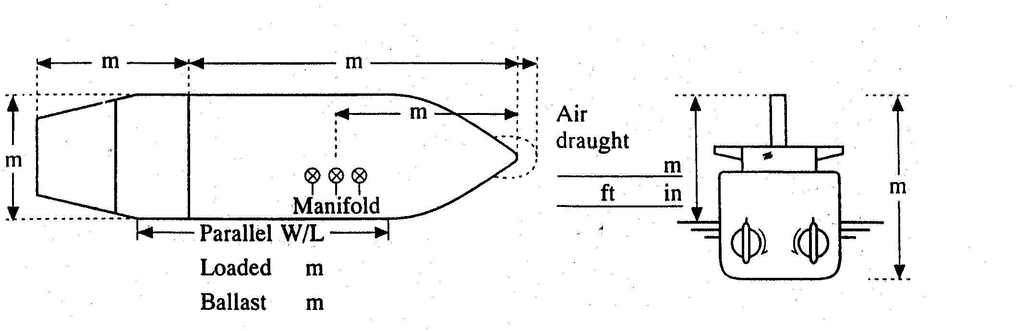
26.5
155.5
44.94
34.25

 | Type of engine WARTSILA 5RT-flex50-D |  |  |  |  | Max. power 7044 kW ( 9583 HP)
 | Manoeuvring engine order |  |  | Rpm/pitch |  | Speed (knots)
 |  |  |  |  |  | Loaded |  |  |  | Ballast
 | Full ahead |  |  | 72 |  | 10.0 |  |  |  | 10.5
 | Half ahead |  |  | 51 |  | 6.0 |  |  |  | 7.0
 | Slow ahead |  |  | 44 |  | 5.5 |  |  |  | 6.0
 | Dead slow ahead |  |  | 35 |  | 4.0 |  |  |  | 4.5
 | Dead slow astern |  |  | 35 |  | Time limit astern |  |  |  | 30 min
 | Slow astern |  |  | 44 |  | Full ahead to full astern |  |  |  | 450 s
 | Half astern |  |  | 50 |  | Max. no. of consec. starts |  |  |  | 20
 | Full astern |  |  | 72 |  | Minimum RPM 28 |  |  |  | 3.2 knots
 |  |  |  |  |  | Astern power |  |  |  | 70 % ahead

STEERING PARTICULARS
Type of rudder SEML-BLANCED STREAM LINED Maximum angle 35
Hard-over to hard-over 19 s
Rudder angle for neutral effect 0 。
Thruster: Bow NIL kW ( HP) Stern NIL kW ( HP)

CHECKED IF ABOARD AND READY
 | Anchors | √ | Indicators:
 | Whistle | √ | Rudder | √
 | Radar √ 3cm | √ 10cm | Rpm/pitch | √
 | ARPA | √ | Rate of turn | √
 | Speed log √ | Doppler: Yes/No | Compass system | √
 | Water speed | √ | Constant gyro error | + 0.1 。
 | Ground speed | √ | VHF | √
 | Dual-axis | √ | Elec. pos. fix. system | √
 | Engine telegraphs | √ | Type | GP-150
 | Steering gear | √
 | Number of power  units operating | √
OTHER INFORMATION:
 |  | Yes | No
1 | Is the ship equipped with an engine or shaft power limiter? EPL or ShaPoli | √
 | If yes, is the limiter mechanical or software based? Limiter mechanical / Software based | √
 | • If the ship is equipped with a mechanical limiter, has it been removed or disabled prior to the pilot boarding the ship?
 | • If the ship is equipped with a software-based limiter, will the ship’s crew be able to override it immediately at the request of the pilot? | √
2 | Can the main engine/s attain the posted manoeuvring power (RPMs) without delay? | √
3 | Are the master and all bridge navigational watchkeepers familiar with the override feature for the EPL? | √
4 | 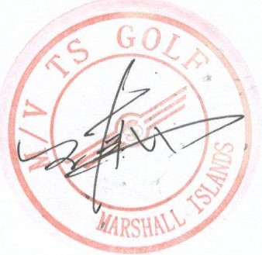  Does the vessel have a risk assessment with appropriate control measures in place for immediate access to the EPL when full manoeuvrability is needed for safe passage? | √

Signature of Master Signature of Boarding Pilot

