Pilot Card

Voy No.: 2601 | Port & Country : MARSDEN POINT, NZ |  |  | Date: 2026.01.13
Agent Details: Inchcape
SHIP PARTICULARS
Name: YANGTZE HAPPINESS |  |  |  | Call Sign: VRLA7
Displacement: 19227 | DWT: 32377 |  |  | Year Built: 2012-08-02
Length: 179.9M | Beam: 28.4M |  |  | Bulbous Bow: YES
Draught Fwd: 4.28 m | Draught Amidships: 5.28 m |  |  | Draught Aft: 6.28 m
Air Draught: 35.9 m | Port Anchor: 11 Shackles |  |  | Starboard Anchor: 11 Shackles
Bow Blind distance: 295.3M(IN BALLAST)/172.74M(LOADED) 1 shackle = 27.5 m/15 fathoms
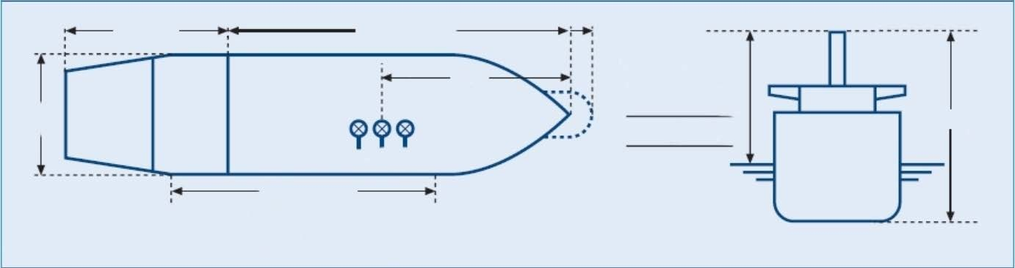  28.9m | 151.0m  MManifold Parallel W/L  Loaded 174.8m  Ballast 118.30m
28.4m |  |  | Air draught  M |  | 42.1 m
MAIN ENGINE
Type: STX - B&W 6S42MC | Max Power: 6480 |  | kW | Max Power: 8686.3 | HP
Type: STX - B&W 6S42MC | RPM/Pitch |  | Loaded Speed (kts) | Ballast Speed(kts)
Sea Full Ahead(Limited by sea depth and EPL) | 117 |  | 12.1 | 12.5
Harbor Full Ahead | 108 |  | 11.0 | 11.5
Half Ahead: | 90 |  | 10.2 | 10.5
Slow Ahead: | 75 |  | 7.5 | 8.5
Dead Slow Ahead: | 50 |  | 5.0 | 5.5
Dead Slow Astern: | 48
Slow Astern: | 75
Half Astern: | 83
Full Astern: | 90 |  | 50% ahead power
Engine Critical RPM:  56-69 | Maximum Number of Consecutive Engine Starts: 12 |  |  | Time from Full Ahead to Full Astern: 420 s
Time Limit Astern: 2.4 MIN |  | Minimum Steering Speed: 4.5kt
Cont.-
STEERING
Number of Propellers: 1 |  | Direction of Turn: Right Handed |  |  |  |  | Propeller Arrangement: CENTRE
Time from Hard-Over to Hard-Over: 11S/23S |  |  |  | Rudder Angle for Neutral Effects: 0 degrees
Thrusters (Positions and Power): N/A |  |  |  | Steering Characteristics: SEMI-SPADE
EQUIPMENT CHECKED AND READY FOR USE
Anchors: | YES |  |  |  |  |  |  | Cleared Away: YES/NO
Compasses: | YES
Compass Error: | 0
Speed Log: | YES |  |  |  |  |  |  | Doppler: YES/NO  Speed: Water/Ground  Axis: Single/Dual
Echo Sounder: | YES
GNSS: | YES |  |  |  |  |  |  | Type:GPS
ECDIS: | YES |  |  |  |  |  |  | FURUNO
X-Band Radar: | YES |  |  |  |  |  |  | ARPA: YES
S-Band Radar: | YES |  |  |  |  |  |  | ARPA: YES
VHF (Including Handheld): | YES
Steering Gear: | YES |  |  |  |  |  |  | Number of Power Units In Use: 2
Engine Telegraphs: | YES
Rudder/RPM/ROT Indicators: | YES
Mooring Winches and Lines: | YES
Navigation Lights: | YES
Whistles: | YES
MOORING CONFIGURATION  (Indicate On Diagram Below) | FWD |  | NBR |  |  |  |  | AFT |  | NBR
MOORING CONFIGURATION  (Indicate On Diagram Below) |  |  | Head |  |  |  |  |  |  | Astern
MOORING CONFIGURATION  (Indicate On Diagram Below) |  |  | Breast |  |  |  |  |  |  | Breast
MOORING CONFIGURATION  (Indicate On Diagram Below) |  |  | Springs |  |  |  |  |  |  | Springs
 |  |  |  |  |  |  |  | (OBTAIN FROM PILOT) |  | TONNES | TUG NAME
MOORING DETALS/PLAN |  | MOORING WINCHES |  | 2+2 |  |  |  | TUG’S  BOLLARD  PULL | NO.1
 |  | MOORING BOLLARD |  | SWL |  | 64T |  | TUG’S  BOLLARD  PULL | NO.2
 |  | CLOSED CHOCK |  | SWL |  | 48T |  | TUG’S  BOLLARD  PULL | NO.3
 |  | ROLLER FAIRLEAD |  | SWL |  | 48T |  |  | NO.4
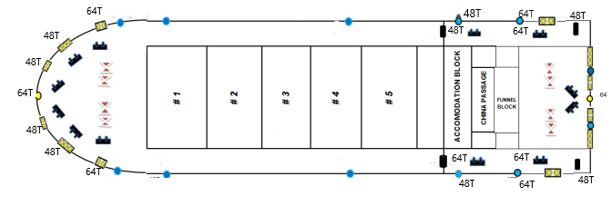

WHEN BOLLARD PULL OF THE TUGS EXCEED THE SWL OF SHIPS MOORING BOLLARDS PILOT/TUGS SHOULD BE ADVISED.
EQUIPMENT OPERATIONAL DEFECTS / OTHER IMPORTANT DETAILS
NIL
OTHER IMPORTANT DETAILS
RPM PERFORM NOT MORE THAN 119.2 (Corresponding to 4360 KW) AS PER REQUIREMENT OF THE EPL&OMM. ABOUT FIVE MINUTES TO DISABLE THE EPL.
Completed by: Verified by : Acknowledged by:

Name : Master Pilot
Rank : Name : XIONG WEIMENG Name： Date:

