Port Name MARSDEN POINT |  |  |  |  |  |  | Date 03 SEPT 2024
Call sign V7PM2 |  |  | Deadweight 29313 tonnes |  |  |  |  | Year built 22/08/2017
Draught aft 9.50 m/ ft in, |  |  |  |  | Forward 7.80 m/ ft in, |  |  |  | Displacement 38512 tonnes

SHIP’S PARTICULARS
Length overall 182.0 m, Anchor chain: Port 11 shackles, Starboard 12 shackles,
Breadth 30.0 m Stern NIL shackles
Bulbous bow No (1 shackle = 27.5 m/ 15 fathoms)
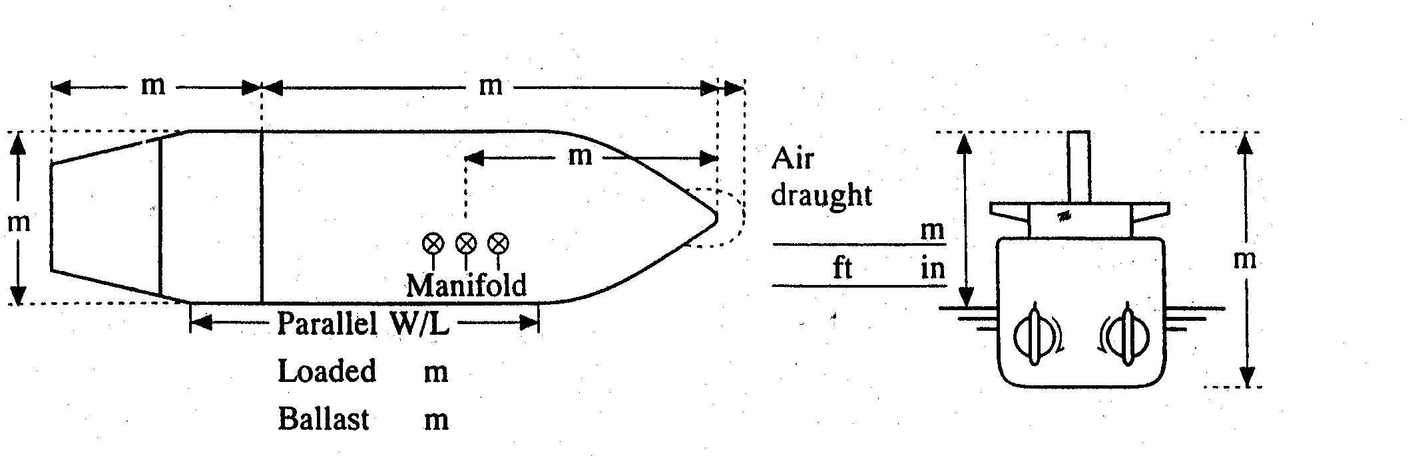
30
44.94
155.5
26.5

 | Type of engine WARTSILA 5RT-flex50-D |  |  |  |  | Max. power 7044 kW ( 9583 HP)
 | Maneuvering engine order |  |  | Rpm |  | Speed (knots)
 |  |  |  |  |  | Loaded |  |  |  | Ballast
 | Full ahead |  |  | 72 |  | 10.0 |  |  |  | 10.5
 | Half ahead |  |  | 51 |  | 6.0 |  |  |  | 7.0
 | Slow ahead |  |  | 44 |  | 5.5 |  |  |  | 6.0
 | Dead slow ahead |  |  | 35 |  | 4.0 |  |  |  | 4.5
 | Dead slow astern |  |  | 35 |  | 3.5 |  |  |  | 4.0
 | Slow astern |  |  | 44 |  | 4.0 |  |  |  | 4.5
 | Half astern |  |  | 50 |  | 5.0 |  |  |  | 5.8
 | Full astern |  |  | 72 |  | 6.8 |  |  |  | 7.5
Time limit astern 30 min CRITICAL RPM RANGE: 53-67
Full ahead to full astern 450 s
Max. no. of consec. Starts 20
Minimum RPM 28 3.2 knots
Astern power 70 % ahead

STEERING PARTICULARS
Type of rudder SEML-BLANCED STREAM LINED Maximum angle 35
Hard-over to hard-over 19 s
Rudder angle for neutral effect 0 。
Thruster: Bow NIL kW ( HP) Stern NIL kW ( HP)
CHECKED IF ABOARD AND READY
 | Anchors |  | √ | Indicators:
 | Whistle |  | √ | Rudder | √
 | Radar √ 3cm |  | √ 10cm | Rpm | √
 | ARPA |  | √
 | Speed log √ |  | Doppler: Yes | Compass system | √
 | Water speed |  | √ | Constant gyro error | + 0.1 。
 | Ground speed |  | √ | VHF | √
 |  |  |  | Elec. pos. fix. system | √
 | Engine telegraphs |  | √ | Type | GP-150
 | Steering gear |  | √
 | 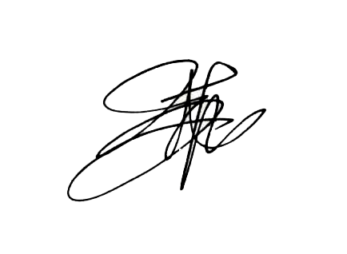  Number of power  units operating |  | √
OTHER INFORMATION:

Master PILOT

