Pilot Card

Voy No.: 2502 | Port & Country: TURANGA, NZ |  |  |  | Date: 20-04-2025
SHIP PARTICULARS
Name: GREAT VANGUARD |  |  |  |  | Call Sign: VRQB6
Displacement: 30438.50MT |  | DWT:19497MT |  |  | Year Built: 2018
Length: 179.95M |  | Beam: 32.00M |  |  | Bulbous Bow: NO
Draught Fwd: 6.71M |  | Draught Amidships: 7.07M |  |  | Draught Aft: 7.35M
Air Draught: 35.05M |  | Port Anchor: 11 Shackles |  |  | Starboard Anchor: 12 Shackles
Bow Blind distance: 150 M 1 shackle = 27.5 m/15 fathoms
30m | 149.95m  Manifold Parallel W/L  Loaded 97.5 m  Ballast 88.1 m
32.0m |  |  |  | Air draught  36.01m |  |  | 42.4m
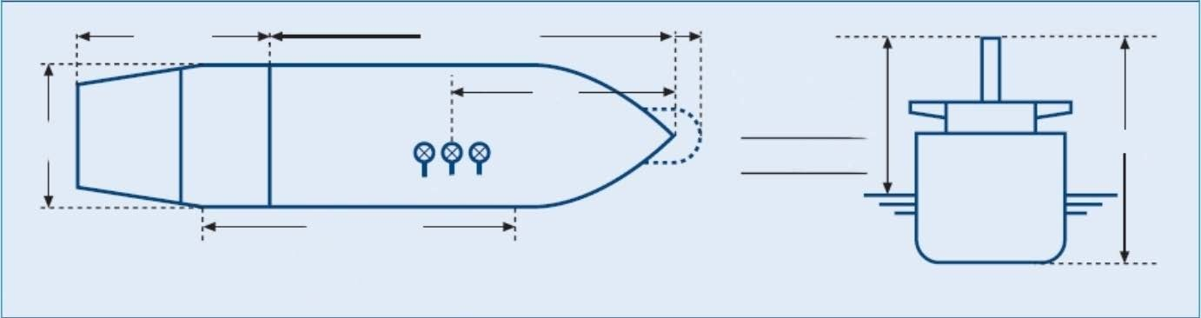
MAIN ENGINE
Type: M.A.N. - B&W 6S50MC  F.P.P. Keyless (KIS), Diam:6000mm |  | Max Power: | 4575 | kW | Max Power: 6225 |  | HP
 |  | RPM/Pitch |  | Loaded Speed (kts) |  | Ballast Speed(kts)
Full Ahead: |  | 68 |  | 9.7 |  | 10.2
Half Ahead: |  | 58 |  | 8.0 |  | 8.6
Slow Ahead: |  | 40 |  | 5.2 |  | 5.8
Dead Slow Ahead: |  | 33 |  | 3.9 |  | 4.5
Dead Slow Astern: |  | 33
Slow Astern: |  | 40
Half Astern: |  | 58
Full Astern: |  | 68 |  | 77% ahead power
Engine Critical RPM: 46-56 |  | Maximum Number of Consecutive Engine Starts:12 |  |  | Time from Full Ahead to Full Astern: 392 s
Time Limit Astern: 30min |  |  | Minimum Steering Speed: 3.9kt

Cont.-
STEERING
Number of Propellers: 1 |  | Direction of Turn: Right Handed |  |  |  |  | Propeller Arrangement: CENTRE
Time from Hard-Over to Hard-Over: 17.58s |  |  |  | Rudder Angle for Neutral Effects: 35 degrees
Thrusters (Positions and Power): N/A |  |  |  | Steering Characteristics: SEMI-SPADE
EQUIPMENT CHECKED AND READY FOR USE
Anchors: | YES |  |  |  |  |  |  | Cleared Away: YES/NO
Compasses: | YES
Compass Error: | YES
Speed Log: | YES |  |  |  |  |  |  | Doppler: YES/NO  Speed: Water/Ground  Axis: Single/Dual
Echo Sounder: | YES
GNSS: | YES |  |  |  |  |  |  | Type:GPS
ECDIS: | YES
X-Band Radar: | YES |  |  |  |  |  |  | ARPA: YES
S-Band Radar: | YES |  |  |  |  |  |  | ARPA: YES
VHF (Including Handheld): | YES
Steering Gear: | YES |  |  |  |  |  |  | Number of Power Units In Use: 2
Engine Telegraphs: | YES
Rudder/RPM/ROT Indicators: | YES
Mooring Winches and Lines: | YES
Navigation Lights: | YES
Whistles: | YES
MOORING CONFIGURATION  (Indicate On Diagram Below) | FWD |  | NBR |  |  |  |  | AFT |  | NBR
 |  |  | Head |  | 44 |  |  |  |  | Astern
 |  |  | Breast |  |  |  |  |  |  | Breast
 |  |  | Springs |  |  |  |  |  |  | Springs
 |  |  |  |  |  |  |  | (OBTAIN FROM PILOT) |  | TONNES | TUG NAME
MOORING DETALS/PLAN |  | MOORING WINCHES |  | 2+2 |  |  |  | TUG’S  BOLLARD  PULL | NO.1
 |  | MOORING BOLLARD |  | SWL |  | 628KN |  |  | NO.2
 |  | CLOSED CHOCK |  | SWL |  | 628KN |  |  | NO.3
 |  | ROLLER FAIRLEAD |  | SWL |  | 628KN |  |  | NO.4
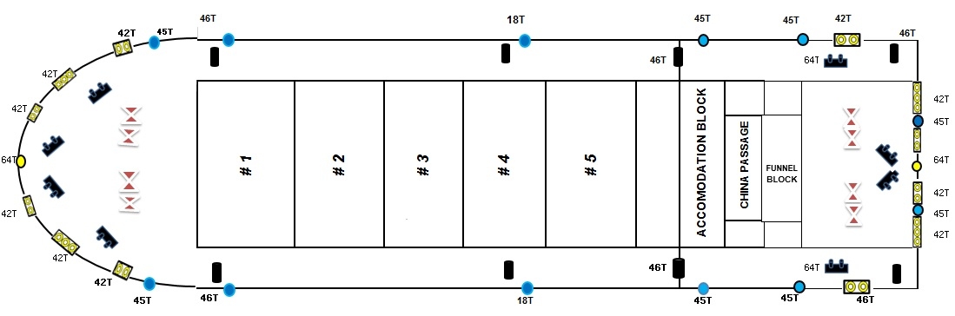

WHEN BOLLARD PULL OF THE TUGS EXCEED THE SWL OF SHIPS MOORING BOLLARDS PILOT/TUGS SHOULD BE ADVISED.
EQUIPMENT OPERATIONAL DEFECTS / OTHER IMPORTANT DETAILS
Nil
OTHER IMPORTANT DETAILS
Completed by: Verified by : Acknowledged by:

Name : Master Pilot
Rank : Name : DUAN YOUHUA
Date:

