Date: | 10/04/2025 | Port: | MARSDEN POINT | VOY. No: | 52
SHIP PARTICULARS
Name: | KEN VISTA |  |  | Call Sign: | 3EYL6
Displacement: |  | DWT: |  | Year Built: | 2011
LOA: | 184.75 m | Beam: | 30.6 m | Bulbous Bow: | YES
Draught FWD: | 10.06 | Draught AFT: | 10.44 | Draught MID: | 10.28
Air Draught: | 33.57 | Port Anchor  Shackles: | 11 | STBD Anchor  Shackles: | 11
(1 Shackle = 27.4 m / 15 Fathoms)
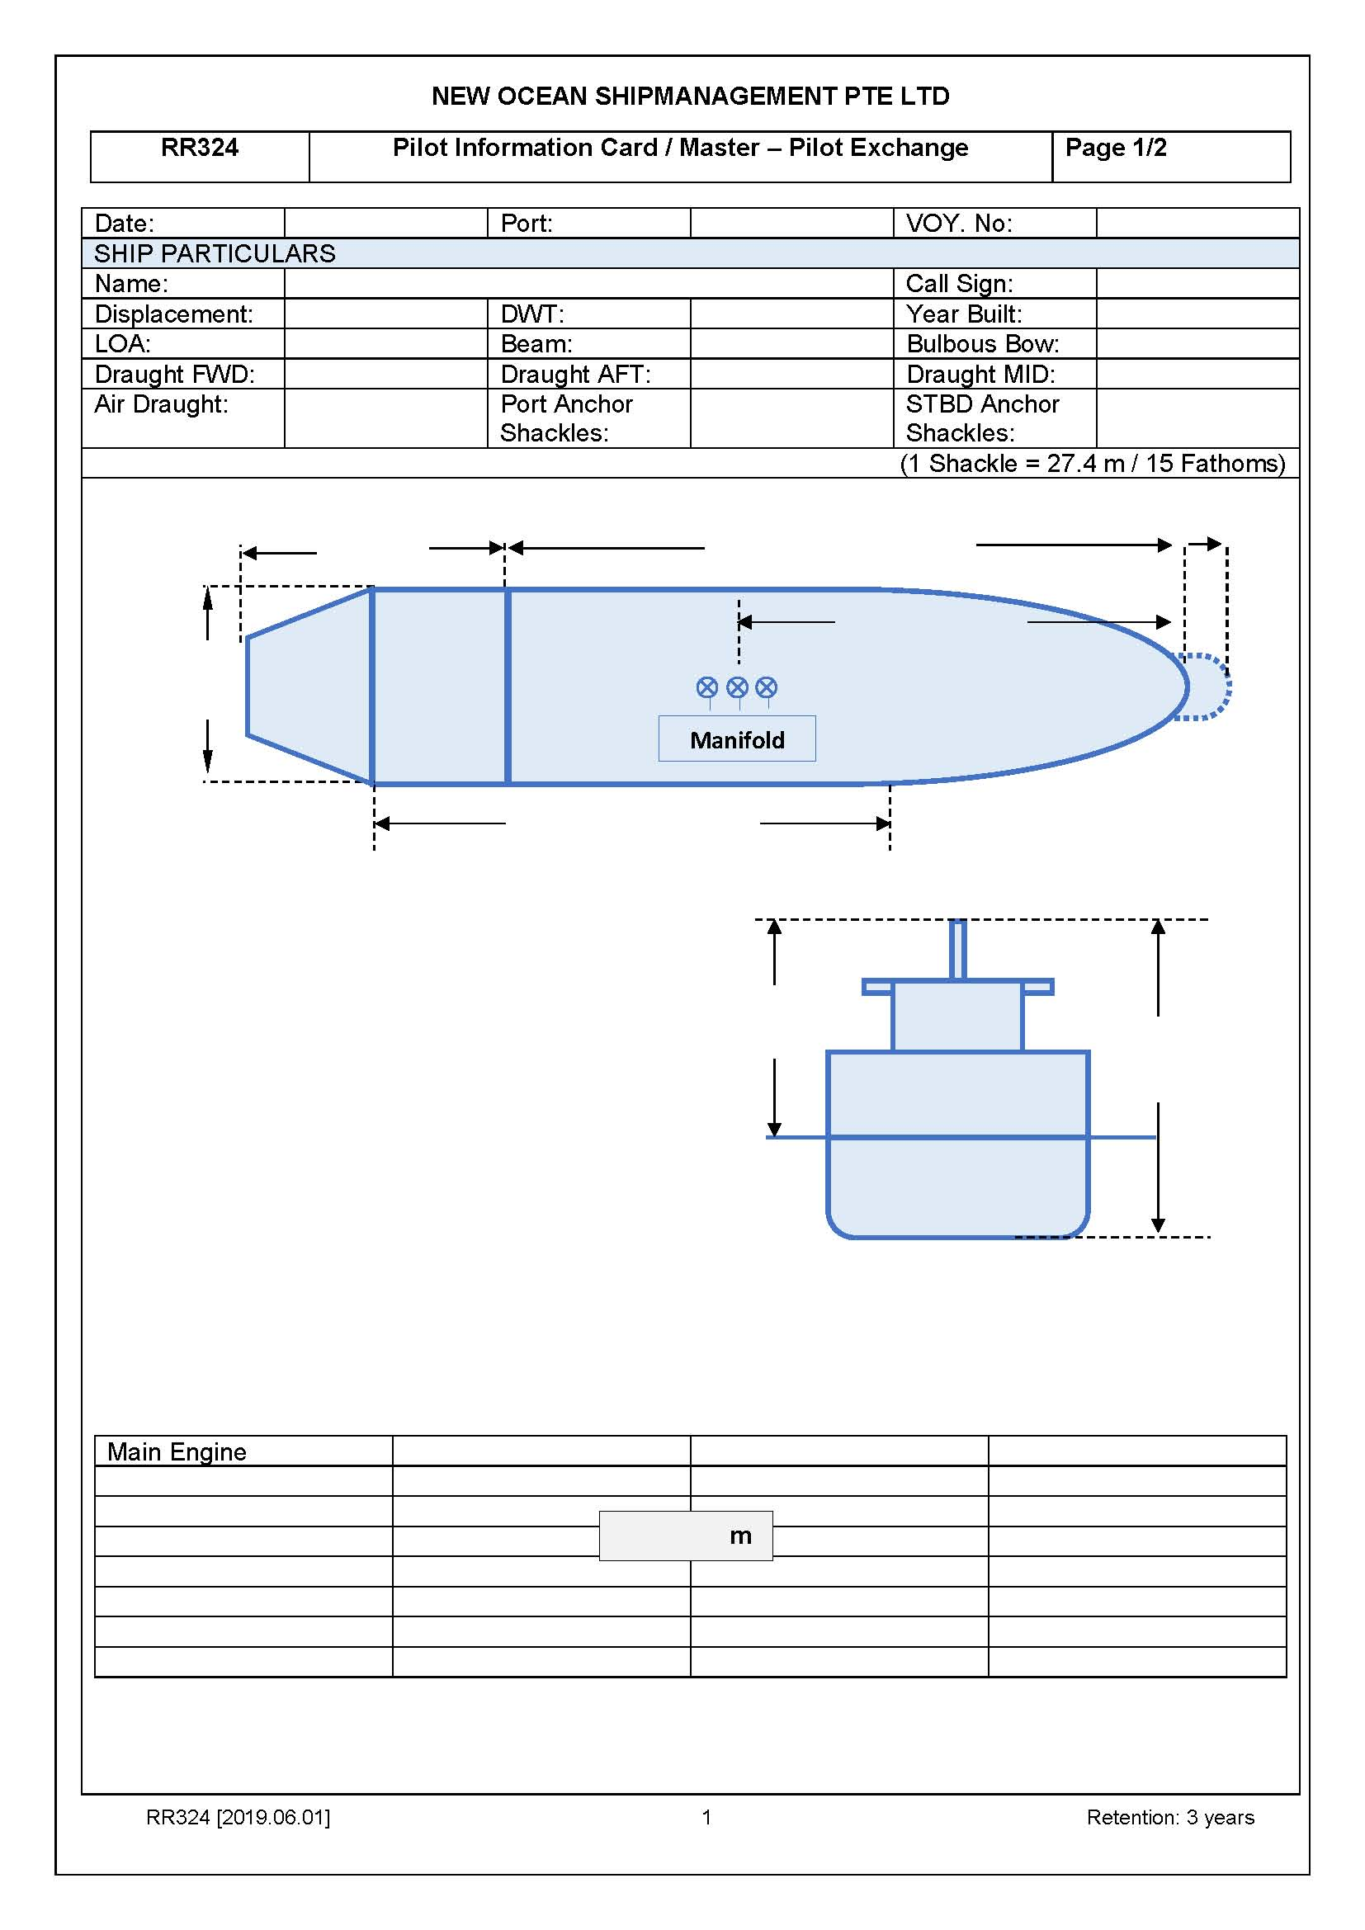
m
Parallel W/L
Loaded: 113.3 m
Ballast: 96.6 m

m
43.63 m
30.6 m m
26.45 m
158.75 m

MAIN ENGINE
Type: | DIESEL ENGINE  HITACHI-MAN B&W 6S46MC-C |  | Max Power: | 6780kW | Max Power: | HP
 |  |  | RPM/Pitch |  | Loaded  Speed (kts) | Ballast  Speed (kts)
Full Ahead: |  |  | 80 (Rev) |  | 11.1 (Kts) | 11.5 (Kts)
Half Ahead: |  |  | 60 (Rev) |  | 8.7 (Kts) | 9.1 (Kts)
Slow Ahead: |  |  | 48 (Rev) |  | 7.1 (Kts) | 7.4 (Kts)
Dead Slow Ahead: |  |  | 36 (Rev) |  | 5.5 (Kts) | 5.7 (Kts)
Dead Slow Astern: |  |  | 36 (Rev)
Slow Astern: |  |  | 48 (Rev)
Half Astern: |  |  | 60 (Rev)
Full Astern: |  |  | 80 (Rev) |  | 40% ahead Power
Engine Critical RPM: |  | 63 - 75 |  | Max. Number of Consecutive Engine Starts: |  | 11
Time Limit  Astern: |  | N/A |  | Time from Full Ahead to Full Astern: |  | 5’ – 20’
Minimum Steering Speed:

STEERING
Number of Propellers: | 1 |  | Type: |  | 4 Bladed Solid Aerofoil Section Keyless
Propeller Arrangement: | Midship |  | Direction of Turn: |  | Left / Right
Rudder Angle for Neutral Effects: | NIL |  | Time Hard to Hard over: |  | 24.3
Thrusters Position: | NIL |  | Thruster Power: |  | NIL (kW / HP)
Controllable pitch: | Yes / No
Number of Rudder: | 1 |  | Maximum rudder angle: |  | 35˚
EQUIPMENT CHECKED AND READY FOR USE
Anchors: |  |  |  | Cleared Away: (YES / NO)
Compass:
Compass Error:
Speed Log: |  |  |  | Doppler: Yes / No  Speed: Water / Ground  Axis: Single / Dual
Echo Sounder:
ECDIS:
X-Band Radar: |  |  |  | ARPA: Yes / No
S-Band Radar: |  |  |  | ARPA: Yes / No
VHF
Steering Gear: |  |  |  | Number of Power Units in use  : 01
Engine Telegraphs:
Rudder/RPM/ROT
Indicators:
Mooring winches and Lines:
Navigation lights:
Whistles:
Flags:
Electronic position fixing equipment:
Min. UKC during the Pilotage
As per passage plan |  | Pilot’s input/comments |  | Actual reading
EQUIPMENT OPERATIONAL DEFECTS
NIL
OTHER IMPORTANT DETAIL
Note: If any variation observed between planned passage and pilot’s intention, master shall update the plan suitably.

Master Name & Signature: | LE QUOC AN | Date / Time:

MASTER/PILOT INFORMATION CHANGE
Name: | KEN VISTA |  | Call sign: | 3EYL6 |  | Flag: |  | PANAMA
IMO Number: | 9527946 |  | Year Built: | 2011 |  | Ship type: |  | BULK CARRIER
Contact name: |  |  |  | VHF Channel:
Other mean of contact:
PILOT BOARDING INSTRUCTION
ETA at P/Station: |  |  |  | Approach Course & Speed:
Boarding Position: |  |  |  | Embarkation Side: |  |  | PORT / STBD / TBA
Requested boarding arrangement:
Safe Distance from  Pilot Vessel (e.g., CJK): |  | Master & pilot agreement of safe  distance from pilot vessel: |  |  | NM
 |  | Note: Company CPA policy to be maintained minimum distance on her abeam: 0.2 nm.
THE TRANSIT TO AND FROM THE BERTH
Route agreed with waypoints and courses, adequate charts? |  |  |  |  |  |  | YES / NO
Speed to be used for the transit?
Vessel movements, any congestion off the berth?
Local traffic regulations to be complied with?
Depth limitations due to tide and/or squat?
Minimum depth on passage? |  |  |  |  |  |  | meters
Location of turning areas including those required for a berthing maneuver? |  |  |  |  |  |  | YES / NO
Abort points?
Emergency or standby anchorage areas? |  |  |  |  |  |  | YES / NO
BERTH AND TUG DETAILS
Intended berth and berthing prospects?
Any limitations such as the maximum/minimum size of vessel, number of bollards, fender capacity?
Turning areas are of sufficient size? (Standard a circle of a diameter three times the length of the vessel) if not, need additional measure. With the help of sketch / diagram, have you discussed with the pilot? How much minimum safe distance, vessel will keep all the time while turning?
Is the Momentum off the vessel minimum safe speed before turning in Basins?
Any air draught restrictions?
Any berthing aids to assist in determining speed when maneuvering?
Any berthing speed limits |  |  |  |  |  |  | Knots
Time required ordering pilot / tugs in an emergency?
Departure procedures for letting go moorings?
Which is first line ashore?
Side Alongside: |  | PORT / STBD |  | Estimated transit time  to berth:
Tug Rendezvous PSN: |  |  |  | Number of Tugs:
Tug Arrangement: |  |  |  | Tug type and power:
Total Bollard pull: |  |  |  | Line to be used: |  |  | Ship / Tug
Ship bollard SWL  (Tug line) |  | Fwd: / Aft: |  | Review SWL of rope/wire to be used by tug (ship’s line or tug’s line), Chock SWL, tug bollard pull, ship’s bollard SWL, etc.
LOCAL WEATHER AND SEA CONDITION
Local Tidal Information
(Heights / Slack times)
Rate & Direction of any current?
When direction of flow changes?
Forecast weather
Expected maximum wind speed
MOORING ARRANGEMENT / MOORING PLAN
Number of lines |  | Head/Stern: 04/04 |  | Breast: |  |  | Spring: 02/02
Sequence of mooring line |  | Head/Stern: |  | Breast: |  |  | Spring:
Maximum maneuvering speed while approaching terminal |  |  |  |  |  |  | knots
Anchor usage |  | PORT / STBD / No Use |  | Line boat availability |  |  | Yes / No
REGULATIONS including VTS reporting, anchor/look-out attendance, max allowable draught
PILOTAGE CHECKLIST
Appropriate scale charts and ENC available with route plotted
Appropriate flags and navigation lights or shapes displayed
Bridge appropriately manned to:
- Maintain a proper look-out
- Monitor the progress of the ship and navigational safety
- Monitor communications between pilot, shore, tugs and mooring craft
- Carry out orders and instructions given by the Master and Pilot
Bridge watch and crew standby arrangements
ECDIS terminals are setup correctly for navigation in pilotage water with route displayed
Engine room and mooring stations regularly updated on pilotage progress
Master/pilot exchange card and pilotage plan agreed
Pilot briefed on the pilot card and wheelhouse poster concerning maneuvering characteristics
Mooring stations informed of berthing arrangements
Pilot informed of any propulsion or steering gear defects or limitations
Pilot informed of ship’s heading, speed, engine setting and draught on arrival on the bridge
Pilot informed of the location of life-saving appliances provided for their use
Working language agreed
Has the ECDIS parameters and settings for the Safety Guard Zone and Safety Depths been discussed with the Pilot.
Orientation of the ECDIS presentation, including the data presentation has been
discussed and shown to the Pilot.
Position cross checking methods discussed.
CONTINGENCY PLAN WHILE TRANSIT / BERTHING / UNBERTHING
Has contingency plan or ship specific risk assessment been made which should be followed in the event of a malfunction or shipboard emergency, identifying possible abort points are safe grounding areas?
Has the contingency plan ben discussed & agreed between pilot and master?
Are both anchors ready for emergency use without any delay?
Is Bow (Stern) thruster ready for operation all the times without any restriction?

OTHER IMPORTANT DETAILS including navigation hazards, ships movements, Speed reduction prior to alteration and any object impeding safe passage while transiting channel

Attach approaching / berthing plan or sketch
NOTE : When approaching the berth at 2 x the breadth of the ship, the vessel should maintain less than 0.6 knots (SOG/GPS). When touching the fender the speed of the vessel should be at 0.2 knot or less (VLCC and VLGC should be at 0.1 knot or less)
Master should be explained by pilot “Speed Reduction Plan for Vessel Approaching Pier in Direction of Arrival”

Master Name & Sign: | LE QUOC AN | Date / Time:
Pilot name & Sign: |  | Date / Time:
Remark:
1. Must take acknowledgement from the Pilot.
2. Any alteration from prepared passage plan should indicated by temporary correction on the original plan with a pen. Same is to be entered in the Deck Logbook also.
3. ECDIS safety settings as per NP056 Appendix A-3 to be shown to Pilot.
4. If the pilot refuses to sign, please leave a record in the designated field and make an entry in the Deck Logbook.

Master – Pilot information exchange reference flow chart

To be provided by PILOT
Port Information
Is the boarding arrangement provided and agreed upon?

Safe boarding arrangement is prepared and agreed with pilot

Berthing Plan
Passage Plan
Is the tug-boat assistance plan reviewed and discussed?
Is the detailed berthing operation plan including mooring operation plan reviewed and discussed?
1. Compare the suggested route with ship’s passage plan
2. Establish the passage route considering all safety measures
Is an approaching route from boarding point to the destination (Berth, Anchorage, SPM) fully reviewed and discussed?
Is there any obstruction/caution point in the route?
(Dolphin Jetty, Submarine Obstruction, Shore construction, navigational warning etc.)
Safe circumstance for navigation
Are the Local weather and tidal information provided?
Is there any notable port regulation?

To be provided by MASTER
Ship’s Particular
Vessel Information
Passage Plan
Berthing Plan
Berthing operation with safety tool box meeting and risk assessment
Share the detailed berthing plan with mooring station.
Standby for mooring stations
Condition of mooring equipment
Comply the all safety measures in all times
Navigational Warning and Safety measures
Position fixing and proper look-out for monitoring of passage plan
Ensure the All shipboard equipment and condition is good condition
Safety Policy (CPA, UKC, Safety Speed)
Maneuvering Character
Machinery Equipment Condition and Specification
Navigational Equipment Condition

