SHIP’ NAME: TS HONOUR VOYAGE NO.: 2502
Port Name: MARSDEN POINT, NEW ZEALAND |  |  |  |  |  | Date 29 MARCH 2025
Call sign V7HP8  Draught aft 6.96 m/ |  |  |  | Dead weigh 14760 tones  Forward 4.49 m |  |  | Year built 2017  Displacement 24012 tones

SHIP’S PARTICULARS
Length overall 182.00 m, Anchor chain: Port 11 shackles, Starboard 12 shackles,
Breadth 30.00 m Stern \ shackles
Bulbous bow Yes/No (1 shackle = 27.5 m/ 15 fathoms)
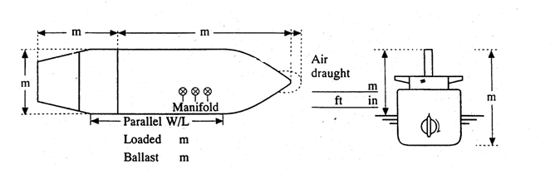
25.3m
156.7m
30m
44.94m
37.98M

Loaded 98.6m
Ballast 89.1m

 |  | Type of engine: WARTSILA 5RT-flex50-D Tier II Delta Tuning Max. power 7044 kW ( HP)
 |  | Manoeuvring engine order | Rpm |  | Speed (knots)
 |  | Manoeuvring engine order |  |  | Loaded |  |  | Ballast
 |  | Full ahead | 72 |  | 10.0 |  |  | 10.5
 |  | Half ahead | 50 |  | 7.0 |  |  | 7.5
 |  | Slow ahead | 44 |  | 5.5 |  |  | 6.0
 |  | Dead slow ahead | 35 |  | 4.5 |  |  | 5.0
 |  | Dead slow astern | -35 |  | Time limit astern |  |  | 30 min
 |  | Slow astern | -44 |  | Full ahead to full astern |  |  | 607 s
 |  | Half astern | -50 |  | Max. no. of consec. starts |  |  | 25
 |  | Full astern | -72 |  | Minimum RPM 35 |  |  | 4.5 knots
 |  |  |  |  | Astern power |  |  | 70 % ahead

STEERING PARTICULARS
Type of rudder : SEMI-SPADE/NACA Maximum angle 2 x 35°
Hard-over to hard-over 22″55 s
Rudder angle for neutral effect ±1.5°
Thruster: Bow kW ( HP) Stern kW ( HP)
CHECKED IF ABOARD AND READY
 | Anchors |  |  | Indicators:
 | Whistle |  |  | Rudder | 
 | Radar  3cm |  |  10cm | Rpm/pitch | 
 | ARPA |  |  | Rate of turn |   Nil
 | Speed log  |  | Doppler: Yes/No | Compass system | 
 | Water speed |  |  | Constant gyro error | + 0.1° 。
 | Ground speed |  |  | VHF | 
 | Dual-axis  Nil |  |  | Elec. pos. fix. System | 
 | Engine telegraphs  2 |  |  | T ype : GP-150  ECDIS
 | Steering gear |  | 
 | Number of power  3  units operating |  | 
OTHER INFORMATION:
 |  | Yes | No
1 | Is the ship equipped with an engine or shaft power limiter? EPL or ShaPoli | V
 | If yes, is the limiter mechanical or software based? Limiter mechanical / Software based
 | • If the ship is equipped with a mechanical limiter, has it been removed or disabled prior to the pilot boarding the ship? | N/A
 | • If the ship is equipped with a software-based limiter, will the ship’s crew be able to override it immediately at the request of the pilot? | V
2 | Can the main engine/s attain the posted manoeuvring power (RPMs) without delay? | V
3 | Are the master and all bridge navigational watchkeepers familiar with the override feature for the EPL? | V
4 | Does the vessel have a risk assessment with appropriate control measures in place for immediate access to the EPL when full manoeuvrability is needed for safe passage? | V

ZHANG ZHAOBIN
Signature of Master Signature of Boarding Pilot

