|  |  |  |  |  |  |  |  |  |  |  |
| --- | --- | --- | --- | --- | --- | --- | --- | --- | --- | --- |
| PILOT INFORMATION CARD | | | | | | | | | | |
| **General Particulars** | | | | | | | | | | |
| Vessel Name | **AMATERAS HARMONY** | | | | | Date | | **APRIL 2025** | | |
| Name of Port | **MARSDEN PT** | | | | | Arrival / Departure | | ARRIVAL | | |
| Agent | **NAUTILUS SHIPPING AGENCY** | | | | | Flag | | **LIBERIA** | | |
| IMO No. | **9791080** | | | | | Call Sign | | **5LBW7** | | |
| Vessel Type | **BULK CARRIER** | | | | | Cargo Type | | **LOGS** | | |
| Year Built | **2021** | | | | |  | |  | | |
| **Additional Communication Information** | | | | | | | | | | |
| Tel | **+65 3125 4670**  **+1 (505)302 3474** | | | Telex | **8770773275138** | | | Email | **master.amaterasharmony@**  **stationsatcommail.com** | |
| **Vessel Particulars** | | | | | | | | | | |
| Displacement (tonnes) | | **34754** | Deadweight (tonnes) | | | | **25390** | Beam | | **30** |
| Gross/ Net Tonnage | | **23770** | Freeboard | | | | **6.95** | Air draft | | **36.94** |
| Port Anchor (shackles) | | **11** | Stbd Anchor (shackles) | | | | **11** | 1 shackle = 27.4 m/15 fathoms | | |
| Length OA (m) | | **179.9** | Breadth (m) | | | | **30** | Bulbous Bow | | ☐ Yes ☐ No |
| Draught - Fwd. (m) | | **7.95** | Draught - Aft (m) | | | | **8.13** | Draught - Amidships(m) | | **8.04** |
| Density of Sea Water = 1.025 | | | | | | | | | | |

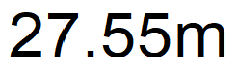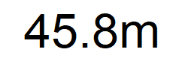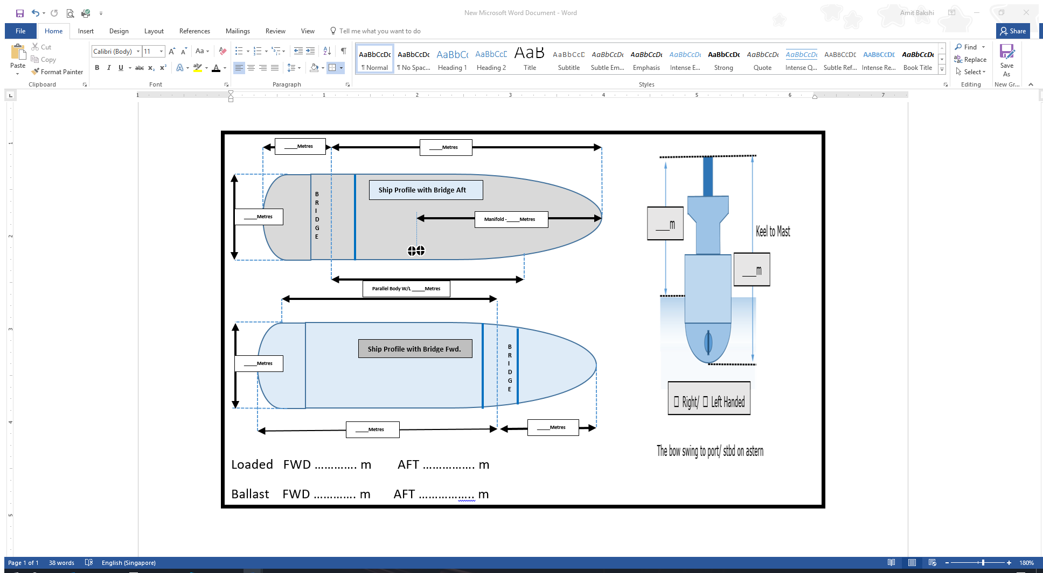

|  |  |  |  |  |  |  |  |  |  |  |  |  |  |  |  |  |  |  |  |  |  |  |  |  |  |  |  |  |  |  |  |  |  |  |  |  |
| --- | --- | --- | --- | --- | --- | --- | --- | --- | --- | --- | --- | --- | --- | --- | --- | --- | --- | --- | --- | --- | --- | --- | --- | --- | --- | --- | --- | --- | --- | --- | --- | --- | --- | --- | --- | --- |
| **Engine Details** | | | | | | | | | | | | | | | | | | | | | | | | | | | | | | | | | | | | |
| Type of Engine | | | | | | | ☐ | | Motor | | | | ☐ | | | Turbine | | | Other | |  | | | | | | | | | | | | | | | |
| Maximum Power (kW) | | | | | | | **6330 KW** | | | | | | | | | | | Maximum Power (HP) | | | | | | | | | | | **8488 HP** | | | | | | | |
| **If Engine Power Limiter (EPL) / Shaft Power Limiter (SHaPoLi) is installed:** | | | | | | | | | | | | | | | | | | | | | | | | | | | | | | | | | | | | |
| Type of Limiter fitted: | | | | | | | Mechanical / Software Based | | | | | | | | | | | **Software** | | | | | | | | | | | | | | | | | | |
| **RPM/Load Limitation** | | | | | | | Max Load **4967** (KW) | | | | | | | | | | | | | | | | Max RPM **101.5** | | | | | | | | | | | | | |
| Does the pilot require the Limiter to be disabled prior to pilot boarding | | | | | | | | | | | | | | | | | | Yes / No | | | | | | | | | | |  | | | | | | | |
| Time required to Disable Limiter | | | | | | | **5 min.** | | | | | | | | | | | | | | | | | | | | | | | | | | | | | |
| Note: The use of a power reserve is only allowed for the purpose of securing the safety of a ship or saving life at sea, consistent with regulation 3.1 of MARPOL Annex VI (e.g. operating in adverse weather and ice infested waters, participation in search and rescue operations, avoidance of pirates and engine maintenance etc) | | | | | | | | | | | | | | | | | | | | | | | | | | | | | | | | | | | | |
| **Manoeuvring Speeds** | | | | | | **RPM/ Pitch** | | | | | | | | | | | | **Loaded Speed** | | | | | | | | **Ballast Speed** | | | | | | | | | | |
| Full Ahead | | | | | | **86** | | | | | | | | | | | | **11.6** Kts | | | | | | | | **12.0** Kts | | | | | | | | | | |
| Half Ahead | | | | | | **74** | | | | | | | | | | | | **10.0** Kts | | | | | | | | **10.3** Kts | | | | | | | | | | |
| Slow Ahead | | | | | | **48** | | | | | | | | | | | | **6.5** Kts | | | | | | | | **6.7** Kts | | | | | | | | | | |
| Dead Slow Ahead | | | | | | **36** | | | | | | | | | | | | **4.9** Kts | | | | | | | | **5.1** Kts | | | | | | | | | | |
| Dead Slow Astern | | | | | | **36** | | | | | | | | | | | | | | | | | | | | | | | | | | | | | | |
| Slow Astern | | | | | | **48** | | | | | | | | | | | | | | | | | | | | | | | | | | | | | | |
| Half Astern | | | | | | **74** | | | | | | | | | | | | | | | | | | | | | | | | | | | | | | |
| Full Astern | | | | | | **86** | | | | | | | | | | | | Full Astern Power | | | | | | | | **70** % of Full Ahead Power | | | | | | | | | | |
| Min. Steering Speed | | | | | | **4kts** | | | | | | | | | | | | Engine Critical RPM | | | | | | | | **56-68** | | | | | | | | | | |
| Maximum number of consecutive starts | | | | | | | | | | | | | | | | | | **11** | | | | | | | | | | | | | | | | | | |
| Time full ahead to full astern | | | | | | **6-47** Sec | | | | | | | | | | | | Time Limit Astern | | | | | | | | **6** Min | | | | | | | | | | |
| **Steering Details** | | | | | | | | | | | | | | | | | | | | | | | | | | | | | | | | | | | | |
| Rudder Number | | | **1** | | | | | Type | | | | | | | | | | **Type Streamline Hanging Semi-balanced Rudder** | | | | | | Maximum Angle | | | | | | **35** °Deg | | | | | | |
| Time hard-over to hard-over | | | | | | | | **23**  Sec | | | | | | | | | | | | | | | | | | | | | | | | | | | | |
| Rudder angle for neutral effect | | | | | | | | **0** °Degrees | | | | | | | | | | | | | | | | | | | | | | | | | | | | |
| Propellers (number) | | | | | | | | **1** | | | | | | | | | | Direction of turn left/ right | | | | | | | | **RIGHT** | | | | | | | | | | |
| Controllable pitch | | | **N/A** | | | | | Bow thruster(s) | | | | | | | | | | **N/A** | | | | | | Stern thruster(s) | | | | | | **N/A** | | | | | | |
| Bow power | | | **N/A** | | | | | | | | | | | | | | | Stern power | | | | | | **N/A** | | | | | | | | | | | | |
| Steering idiosyncrasies | | | | | | | | **N/A** | | | | | | | | | | | | | | | | | | | | | | | | | | | | |
| **Equipment** | | | | | **Status** | | | | | | **Other Particulars** | | | | | | | | | | | | | | | | | | | | | | | | | |
| Anchors | | | | | **Cleared** | | | | | | Length of cable | | | | | | | | | **11 s/s** | | | | Cleared away | | | | | | | ✔ | | Yes | ☐ | | No |
| Speed Log | | | | | **Good** | | | | | | Water/ Ground | | | | | | | | | **water** | | | | Single/ dual axis | | | | | | | **single** | | | | | |
| Gyro compass system | | | | | **Good** | | | | | | Gyro error | | | | | | | | | 0.3 Deg E | | | | Deviation | | | | | | | 3 Deg E | | | | | |
| Magnetic System | | | | | | | | | **Reflector type** | | | | | | | | | | | | | | | | |
| Steering gear | | | | | **Good** | | | | | | Number of power units in use | | | | | | | | | | | | | **1** | | | | | | | | | | | | |
| X-Band radar | | | | | **Good** | | | | | | ARPA | | | | | | | | | | | ☐ | | Yes | | | | ☐ | | | No | | | | | |
| S-Band radar | | | | | **Good** | | | | | | ARPA | | | | | | | | | | | ☐ | | Yes | | | | ☐ | | | No | | | | | |
| Electronic position fixing | | | | | **LOP** | | | | | | Type | | | | **FURUNO GPS** | | | | | | | | | **NO. 1** | | | | | | | **NO. 2** | | | | | |
| Whistle | | | | | **Good** | | | | | | | | | | | | | | | | | | | | | | | | | | | | | | | |
| Flags | | | | | **Hoisted** | | | | | | | | | | | | | | | | | | | | | | | | | | | | | | | |
| Echo sounder | | | | | **Good** | | | | | | | | | | | | | | | | | | | | | | | | | | | | | | | |
| Rudder/ RPM/ ROT indicators | | | | | **Good** | | | | | | | | | | | | | | | | | | | | | | | | | | | | | | | |
| Engine telegraphs | | | | | **Good** | | | | | | | | | | | | | | | | | | | | | | | | | | | | | | | |
| VHF | | | | | **Good** | | | | | | | | | | | | | | | | | | | | | | | | | | | | | | | |
| Mooring winches and lines | | | | | **Good** | | | | | | | | | | | | | | | | | | | | | | | | | | | | | | | |
| Voyage Data Recorder | | | | | **Good** | | | | | | | | | | | | | | | | | | | | | | | | | | | | | | | |
| For Vessels Fitted with ECDIS approved as the primary means of Navigation. | | | | | | | | | | | | | | | | | | | | | | | | | | | | ☐ | | Yes | | | ☐ | No | | |
| ECDIS Make | | **TOKYO KEIKI** | | | | | | | Model | | | | | **EC-8600** | | | | | | | | | Type | | | | **SPECIFIC** | | | | | | | | | |
| ENC’s Available for the Port / Approaches | | | | | | | | | | | | **YES** | | | | | | | | | | | | | | | | | | | | | | | | |
| Updates Available and applied | | | | | | | | | | | | **15 /25** | | | | | | | | | | | | | | | | | | | | | | | | |
| ECDIS back-up procedures in use | | | | | | | | | | | | **YES** | | | | | | | | | | | | | | | | | | | | | | | | |
| Local Warnings held onboard | | | | | | | | | | | | **YES** | | | | | | | | | | | | | | | | | | | | | | | | |
| Any Non-Standard Configuration of ECDIS | | | | | | | | | | | | **NONE** | | | | | | | | | | | | | | | | | | | | | | | | |
| ECDIS Management Card prominently displayed. | | | | | | | | | | | | | | | ☐ | | Yes | | | | ☐ | | | | No | | | | | | | | | | | |
| **SWL (Safe Work Load) bollard used for tug(s)** | | | | | | | | | | | | | | | | | | | | | | | | | | | | | | | | | | | | |
| Fwd1 | **64T** | | | Fwd2 | | | | | | **78T** | | | | | | | Fwd3 | | | | | **64T** | | | | Fwd4 | | | | | **64T** | | | | | |
| Aft1 | **64T** | | | Aft2 | | | | | | **78T** | | | | | | | Aft3 | | | | | **64T** | | | | Aft3 | | | | | **64T** | | | | | |
| **Equipment operational defects** | | | | | | | | | | | | | | | | | | | | | | | | | | | | | | | | | | | | |
| **NIL** | | | | | | | | | | | | | | | | | | | | | | | | | | | | | | | | | | | | |
| **Details of vessel mooring arrangement/ pattern** | | | | | | | | | | | | | | | | | | | | | | | | | | | | | | | | | | | | |
|  | | | | | | | | | | | | | | | | | | | | | | | | | | | | | | | | | | | | |
| **Other important details** | | | | | | | | | | | | | | | | | | | | | | | | | | | | | | | | | | | | |
|  | | | | | | | | | | | | | | | | | | | | | | | | | | | | | | | | | | | | |
| Pilot familiarized with operational controls of navigational equipment | | | | | | | | | | | | | | | | | | | | | | | | | | | ☐ | | | Yes | | ☐ | | | No | |
| Location of Pilot’s EEBD (Emergency Escape Breathing Device) and lifejacket | | | | | | | | | | | | | | | | | | | | | | | | | | | **EEBD- BRIDGE STBD EXIT DOOR**  **LIFEJACKET- ELECTRICAL ROOM** | | | | | | | | | |

|  |  |  |  |
| --- | --- | --- | --- |
| **Master’s Name** | **CAPT. ARNOLD S. VINUYA** | **Pilot’s Name** |  |
| **Signature** |  | **Signature** |  |

*This form shall be prepared for every Pilot Boarding and retained for a period of at least 3 years.*