(Pilot Card)
Arrival: √ 07 JULY 2024 | Shifting: |  |  |  |  | Departure:
SHIP PARTICULARS
Name: NEMRUT BAY |  |  |  |  | Call Sign: 3FGW5
Displacement: 29,030.31 T |  |  | DWT: 20,807.3 T |  | Year Built: 2019
Length: 179.97 M |  |  | Beam: 30 M |  | Bulbous Bow: YES
Draft FWD: 6.62 M |  |  | Draft AFT: 7.22 M |  | Draft Midships: 6.92 M
Freeboard: 6.83 M |  |  | Port Anchor  shackle: 10 SHACKLES |  | Stbd Anchor  shackle: 10 SHACKLES
Air Draft: 34.86 M
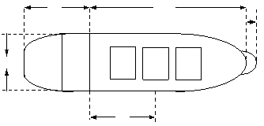
24.419 M 153.55 M 1 shackle = 27.5 m / 15 fathoms
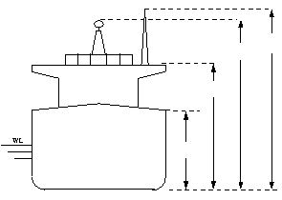
42.08mMMMmM

30.00 M

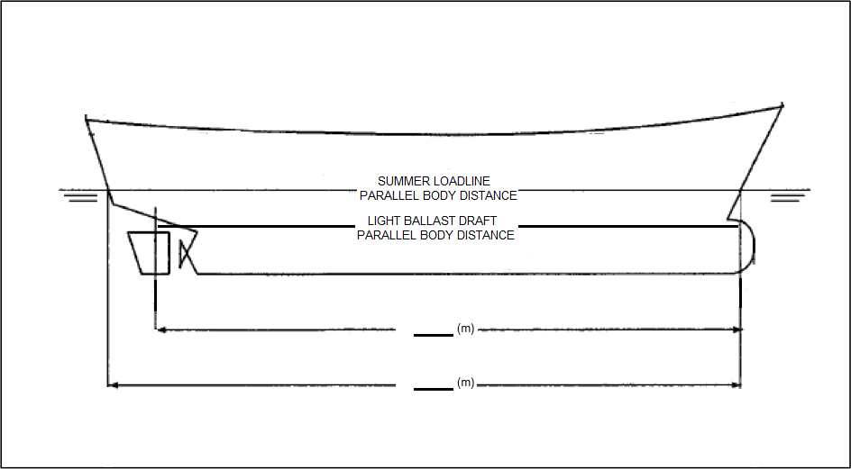
14.05mMMMmM

MAIN ENGINE
Type: |  | Max Power Kw: |  | Max Power HP:
 |  | RPM/Pitch |  | Loaded Speed (Kts) |  |  | Ballast Speed (Kts)
Full Ahead: |  | 76 |  | 9.97 |  |  | 9.97
Half Ahead: |  | 55 |  | 7.13 |  |  | 7.13
Slow Ahead: |  | 46 |  | 6.12 |  |  | 6.12
Dead Slow Ahead: |  | 39 |  | 5.19 |  |  | 5.19
Dead Slow Astern: |  | 39 |  | 6.12 |  |  | 6.12
Slow Astern: |  | 46 |  | 7.31 |  |  | 7.31
Half Astern: |  | 55
Full Astern: |  | 76 |  | 30 % Ahead power
Engine Critical RPM: 61-73 |  | Max. No. of Consecutive  Engine Start: 12 TIMES |  | Time From full Ahead to full  Astern: 3 MINS 12 SEC
Time Limit Astern: |  | Min. Steering Speed:

Propulsion / Propeller
Type of Propeller: |  |  |  | Number of Propeller: 1
STEERING
Time from Hard-Over to hard-Over: 22 SECS |  |  |  | Rudder angle for neutral effects: 0 DEG
Rudder Number: 1 |  | Rudder Type: RIGHT HANDED |  |  |  | Rudder Number: 1
Thruster: Bow, kw/ph: N/A |  |  |  | Steering Characteristics: IDIOSYNCRAISIS
EQUIPMENT CHECKED AND READY FOR USE
Anchors | ✓ |  |  |  | Compass Error |  | 0.2E
Compasses | ✓ |  |  |  | Echo Sounder |  | ✓
Speed Log | ✓ |  |  |  | ECDIS |  | ✓
GNSS / GPS | ✓ |  |  |  | Steering gear |  | ✓
Radar S-Band | ✓ |  |  |  | Bow Thruster |  | N/A
Radar X-Band | ✓ |  |  |  | Rudder / RPM/ROT Indicators |  | ✓
VHF Handheld | ✓ |  |  |  | Mooring winch & Lines |  | ✓
Engine Telegraphs | ✓ |  |  |  | Whistle |  | ✓
Navigational Lights | ✓

 | MASTER |  |  | PILOT (Full Name & Signature)
 | (WITH SHIP’S STAMP)

Date/Time:

Date/Time:

Note: For Bridge File. Shall send to the Company only if requested.

